**Electronic supplement**

Titel: Habitat alteration impacts predation risk in an aposematic amphibian

Authors: Doriane Hagnier1,2† , Carolin Dittrich1,3§ †, Myrna Van den Bos1,4  and Bibiana Rojas1§

1 Department of Interdisciplinary Life Sciences, Konrad Lorenz Institute of Ethology, University of Veterinary Medicine Vienna, Vienna, Austria

2 Department of Biology, Aarhus University, Aarhus, Denmark

3 Department of Biology and Environmental Sciences, University of Jyväskylä, Jyväskylä, Finland

4 Department of Biology, Graduate School of Life Sciences, Utrecht University, Utrecht, The Netherlands

†These authors contributed equally to this work

*Authors to whom correspondence should be addressed:*

*carolin.dittrich@vetmeduni.ac.at;*  ORCID:0000-0002-6715-7294

*bibiana.rojas@vetmeduni.ac.at;*  ORCID:0000-0002-6715-7294

**Supplementary Information**

**Methods:**

*Assessment of “predation attempts”*

We established several references for the mammal bite marks by using skulls of different potential predator and non-predator species from the mammal collection of the Natural History Museum of Vienna. Based on reports about predation on salamanders (Thiesmeier and Grossenbacher 2004), and on their known occurrence in the BRWW, we chose the following species: European badger (*Meles meles*), red fox (*Vulpes vulpes*), pine marten (*Martes martes*), European polecat *(Mustela putorius),* least weasel *(Mustela nivalis),* wild boar (*Sus scrofa*), grey wolf (*Canis lupus*), common rat *(Rattus norvegicus),* common shrew (*Sorex araneus),* European pine vole (*Microtus subterraneus*), bank vole (*Clethrionomys glareolus*),red deer *(Cervus elaphus),* European hedgehog *(Erinaceus europaeus),* Eurasian pygmy shrew *(Sorex minutus),* roe deer *(Capreolus capreolus),* red squirrel *(Sciurus vulgaris),* wood mouse *(Apodemus sylvaticus)* and yellow-necked mouse *(Apodemus flavicollis).* We placed a clay model between the teeth of the different skulls with different angles and photographed the marks with a millimetre scale to improve the accuracy of our bite mark identification (Fig. S1).

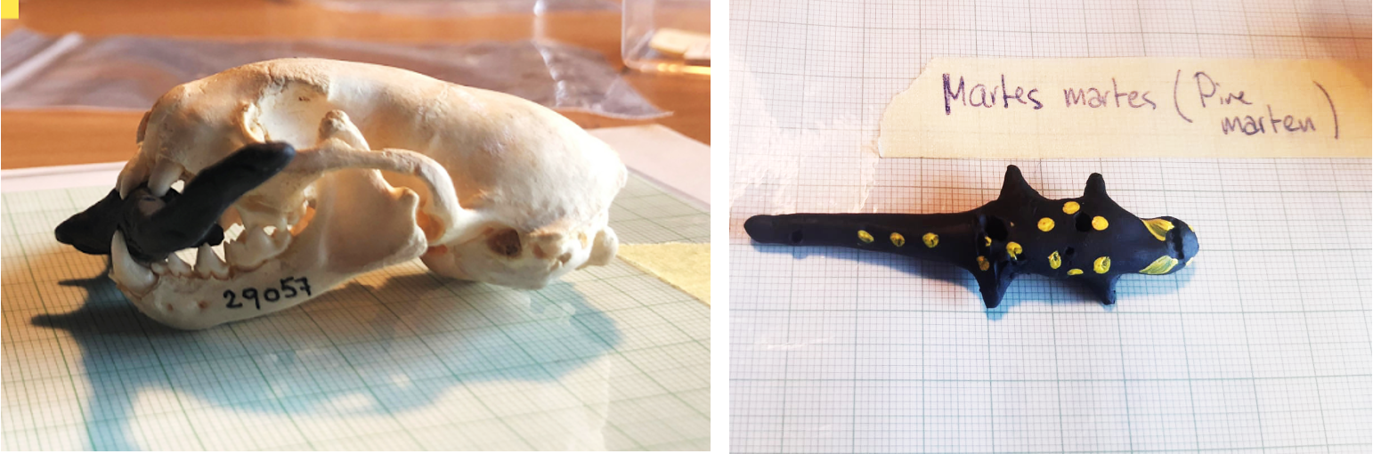

**Fig. S1** Skull of a pine marten (*Martes martes*) and its imprints on a salamander clay model

*Details on Permutations*

We constructed a 'random null model' for each response variable (e.g., forest type or treatment). This model serves as a basis for comparison and is created by randomising one of the conditions while maintaining all other aspects of the data intact. Specifically, we sampled the permutation of the condition of interest (e.g., protected/managed or LM/SM) to generate a new dataset with the same characteristics as the original but with randomised condition labels. Next, we calculated the difference in proportions between the conditions for each newly created dataset. This involved comparing the number of occurrences or 'attacks' in one condition against the other. We repeated this process 10,000 times, generating a distribution of differences in proportions under the null hypothesis that there is no true difference between the conditions. Subsequently, we compared the observed difference in proportions from our actual data to this random distribution. We counted how many times the differences in proportions from the null distribution were equal to or greater than the observed difference. This count represents the frequency at which such extreme differences occurred by chance alone. Finally, we computed a p-value by dividing this count by the total number of iterations (10,000), providing a measure of the likelihood of observing a difference as extreme as, or more extreme than, the one in our actual data purely by chance. A smaller p-value suggests that the observed difference is less likely to have occurred by chance alone, indicating statistical significance. Additionally, we visualised the results using a histogram, which displays the distribution of differences in proportions from the random null model. The observed difference is represented by a blue dashed line, while red lines denote the 95% confidence interval of the null distribution.

**Results:**

Permutations Bird attacks

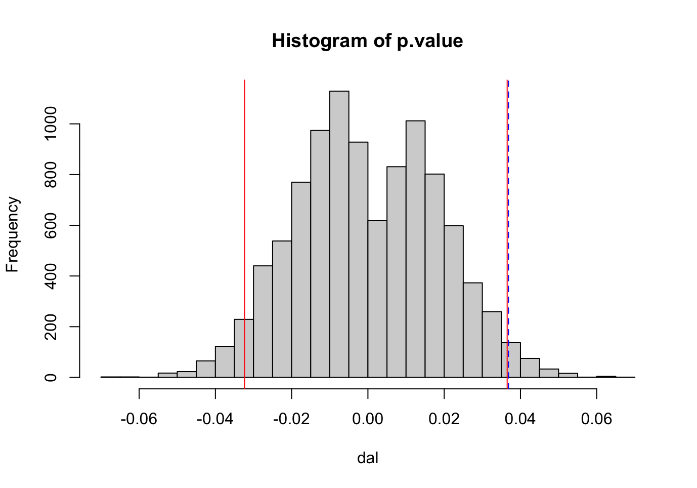

**Fig. S2** Histogram showing the permuted p-value distribution for the comparison of bird attacks on plasticine models in the two forest zones (managed vs. protected). The observed p-value (blue dashed-line) lies outside of the permuted 0.025 and 0.975 quantile (red lines)

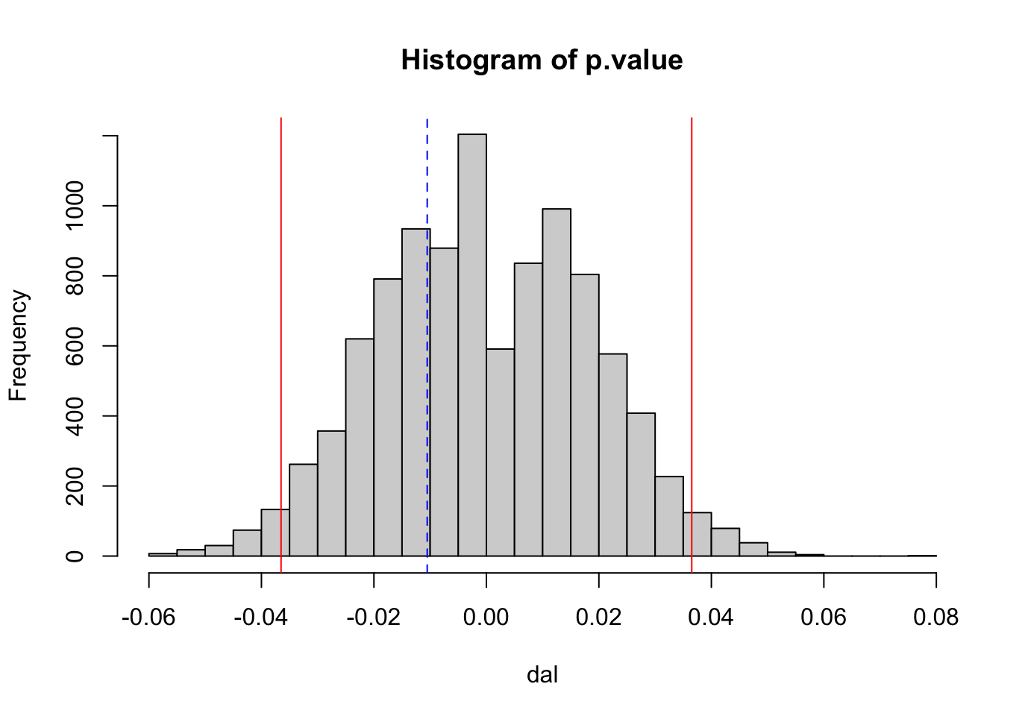

**Fig. S3** Histogram showing the permuted p-value distribution for the comparison of bird attacks on plasticine model morph (SM vs. LM). The observed p-value (blue dashed-line) lies inside of the permuted 0.025 and 0.975 quantile (red lines)

Permutations Mammal attacks

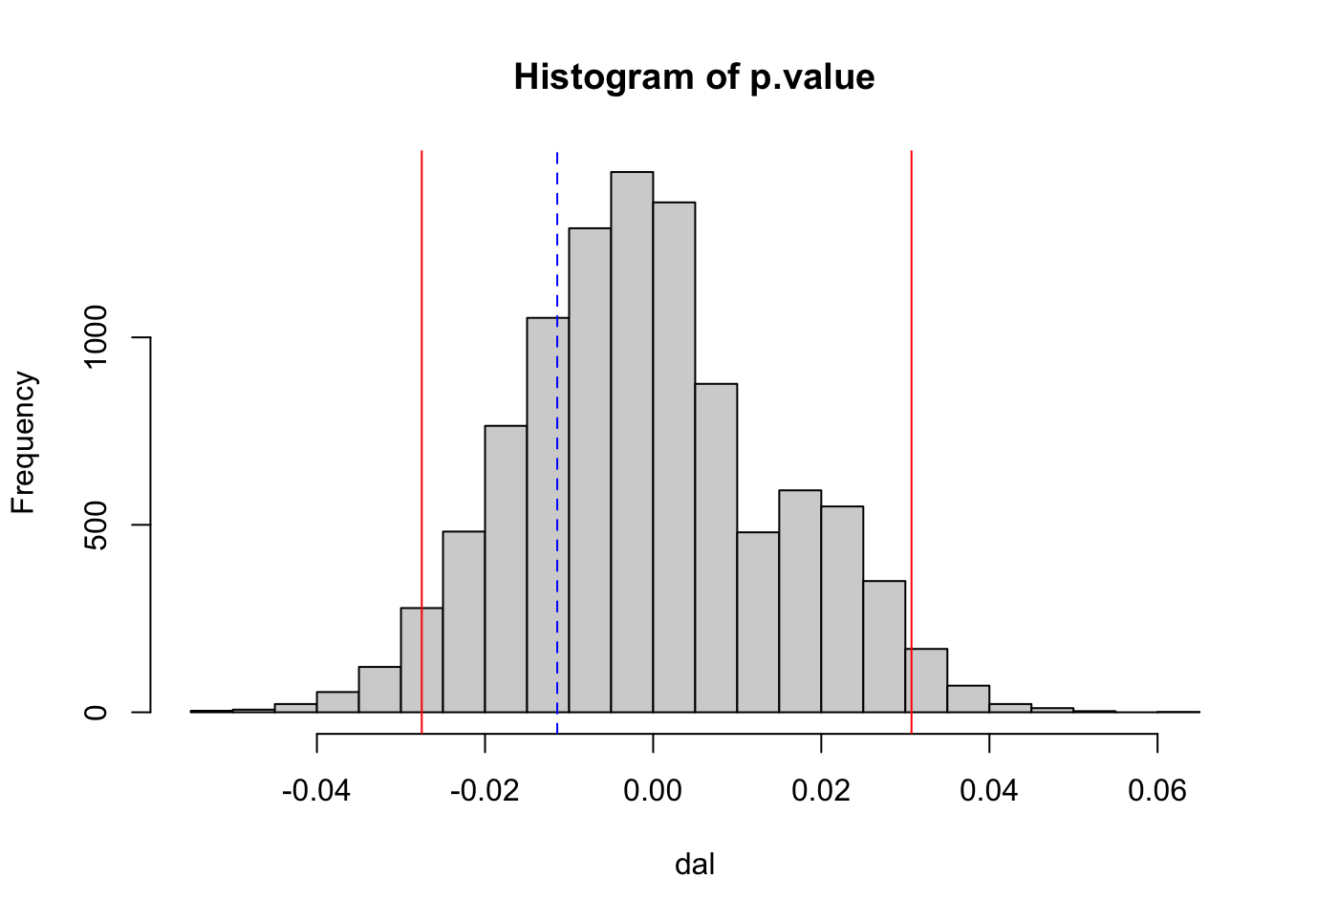

**Fig. S4** Histogram showing the permuted p-value distribution for the comparison of mammal attacks on plasticine models in the two forest zones (managed vs. protected). The observed p-value (blue dashed-line) lies inside of the permuted 0.025 and 0.975 quantile (red lines)

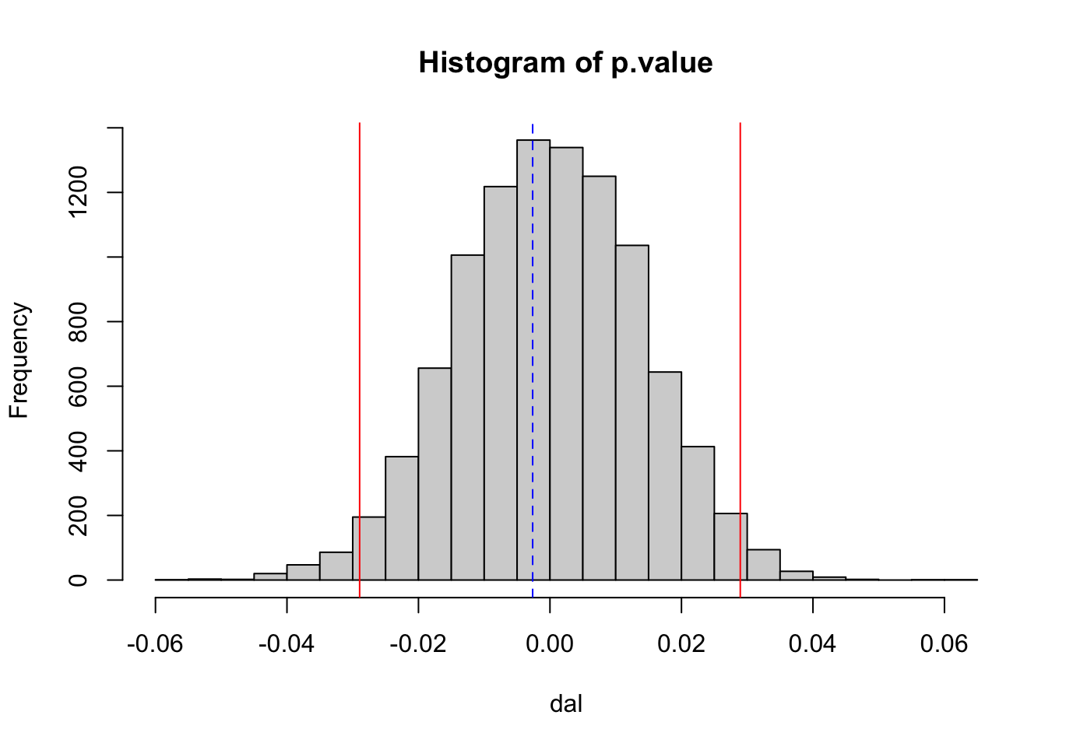

**Fig. S5** Histogram showing the permuted p-value distribution for the comparison of mammal attacks on plasticine model morph (SM vs. LM). The observed p-value (blue dashed-line) lies inside of the permuted 0.025 and 0.975 quantile (red lines)

**Generalized linear models with negative binomial distribution and log link**

**Bird attacks**

|  |  |  |  |  |  |
| --- | --- | --- | --- | --- | --- |
| Negative binomial model glm.nb(n_attack_bird~shannon index+forest zone) | | | | | |
| Parameter | Estimate | Std. Error | z-value | p-value | 95% CI [CI_lower, CI_upper] |
| Intercept | -0.01 | 0.37 | -0.03 | 0.98 | -0.7928522; 0.7148131 |
| Shannon Index | 0.65 | 0.49 | 1.32 | 0.19 | -0.3456698; 1.6884378 |
| managed | 0.57 | 0.42 | 1.38 | 0.17 | -0.2357539; 1.3939987 |
| Dispersion Parameter (theta) | 2.71 | | | | |
| Log-Likelihood | -85.98 | | | | |
| AIC | 93.98 | | | | |
| Pseudo-R² | 0.17 | | | | |

|  |  |  |  |  |  |
| --- | --- | --- | --- | --- | --- |
| Negative binomial model glm.nb(n_attack_bird ~ simpson index + forest zone) | | | | | |
| Parameter | Estimate | Std. Error | z-value | p-value | 95% CI [CI_lower, CI_upper] |
| Intercept | -0.08 | 0.39 | -0.22 | 0.83 | -0.8809027; 0.6468671 |
| Simpson Index | 1.40 | 0.90 | 1.55 | 0.12 | -0.3970363; 3.2380226 |
| managed | 0.55 | 0.40 | 1.38 | 0.17 | -0.2363851; 1.3520467 |
| Dispersion Parameter (theta) | 3.01 | | | | |
| Log-Likelihood | -85.37 | | | | |
| AIC | 93.37 | | | | |
| Pseudo-R² | 0.19 | | | | |

**Mammal attacks**

|  |  |  |  |  |  |
| --- | --- | --- | --- | --- | --- |
| Negative binomial model glm.nb(n_attack_mammal~shannon index * forest zone) | | | | | |
| Parameter | Estimate | Std. Error | z-value | p-value | 95% CI [CI_lower, CI_upper] |
| Intercept | 1.29 | 0.49 | 2.62 | 0.01 | 0.3052219; 2.4524718 |
| Shannon Index | -3.38 | 1.39 | -2.43 | 0.02 | -6.8139050; -0.8016447 |
| managed | -0.85 | 1.00 | -0.85 | 0.40 | -2.8852654; 1.1830250 |
| Shannon:managed | 3.13 | 1.76 | 1.78 | 0.08 | -0.2765603; 7.0950942 |
| Dispersion Parameter (theta) | 1.10 |  | | | |
| Log-Likelihood | -70.74 |
| AIC | 80.74 |
| Pseudo-R² | 0.24 |

|  |  |  |  |  |  |
| --- | --- | --- | --- | --- | --- |
| Negative binomial model glm.nb(n_attack_mammal ~ simpson index * forest zone) | | | | | |
| Parameter | Estimate | Std. Error | z-value | p-value | 95% CI [CI_lower, CI_upper] |
| Intercept | 1.25 | 0.48 | 2.63 | 0.01 | 0.3114856; 2.341347 |
| Simpson Index | -5.89 | 2.42 | -2.43 | 0.02 | -11.7658568; -1.532932 |
| managed | -0.83 | 1.02 | -0.82 | 0.41 | -2.8479518; 1.196474 |
| Simpson:managed | 5.49 | 3.18 | 1.73 | 0.08 | -0.5231012; 12.424267 |
| Dispersion Parameter (theta) | 1.15 |  | | | |
| Log-Likelihood | -70.35 |
| AIC | 80.35 |
| Pseudo-R² | 0.26 |

**Attached files:**

Data on forestry patches and attacks per patch “forest_div.csv”

Variables:

location (names of the six locations)

manual (forest inventory patch number for identification)

core (protected/core and managed)

nstrata (number of strata per patch, 1-3, 1 no rejuvenation only on strata in the patch)

perstrata1 (percent of coverage of strata1 in that patch)

perstrata2 (percent of coverage of strata2 in that patch)

perstrata3 (percent of coverage of strata3 in that patch)

strata1age (mean age of strata1 per patch)

strata2age (mean age of strata2 per patch)

strata3age (mean age of strata3 per patch)

nspecies (number of tree species per patch)

simp (Simpson index of diversity, calculated based on the abundance per tree species per patch, weighted by coverage percent of strata)

shan (Shannon index, calculated based on the abundance per tree species per patch, weighted by coverage percent of strata)

n_attacks_bird (number of attacks by birds within the specific patch)

n_attacks_mam (number of attacks by mammals within the specific patch)

Data on model attacks “attacks_data.csv”

Variables:

location (names of the six locations)

core (0= managed forest zone; 1=protected forest zone)

transectid (transect identifier based on location and number of transect within a location)

treatm (morph type for each plasticine model, SS= small spots = small markings in manuscript; LS= large spots = large markings in manuscript)

fate (0= no predation, 1 = predation)

predtype (predator type, none = no predation at all, bird= bird marks/predation, mammals = mammal marks/predation, various = mammal and bird marks/predation)

Headatt (attacks on the head, binomial, 0= no, 1=yes)

birdatt (attacks by birds, binomial, 0= no, 1=yes)

mammatt (attacks by mammals, binomial, 0= no, 1=yes)

missing (models were found after deploying time, binomial, 0= no, 1=yes), was only used for filtering data set for models that could be retrieved

destroyed (models that have been destroyed completely, binomial, 0=no, 1=yes), was only used for filtering data set for models that could be retrieved and identified

time (number of days the models have been deployed in the transects)

rodents (marks left by rodent incisors, binomial, 0= no, 1=yes)

R Script to reproduce all analysis described and recreate all figures

“Script_Rcode_Hagnier_Dittrich.R”